**Cheeseburger Sliders**

Name: Jomas Benfell  
Date Submitted: Friday 1st March 2024

Page 1. Initial Page

Page 2. References

Page 3. Flowchart for Recipe

Page 4. Flowchart for Recipe - Continued

Page 5. Beginning of Pseudocode

Page 6, Pseudocode - Continued

Page 7. Application of Design Possibilities – Amount of Sliders (Recipe Adjustment)

Page 8. Amount of Sliders (Recipe Adjustment) - Continued

Page 9. Application of Design Possibilities – Adding Ingredients

Page 10. Adding Ingredients - Continued

Page 11. Application of Design Possibilities **-** Applying Both Design Possibilities Into One

Page 12. Applying Both Design Possibilities Into One - Flow Chart Complete

Page 13. Applying Both Design Possibilities Into One – Flow Chart Complete Continued

Page 14. Applying Both Design Possibilities Into One – Pseudocode Complete Continued

Page 15. Applying Both Design Possibilities Into One – Pseudocode Complete Continued

Page 16. Applying Both Design Possibilities Into One – Pseudocode Complete Continued

Page 17. Applying Both Design Possibilities Into One – Pseudocode Complete Continued

Page 18. Applying Both Design Possibilities Into One – Pseudocode Complete Continued

Page 19. Conclusion

**References**

Recipe - <https://natashaskitchen.com/cheeseburger-sliders/> (Note: My recipe is slightly modified and designed with half of the amount in mind, but is based on this recipe.)

Flowcharts Creation - <https://app.diagrams.net/>

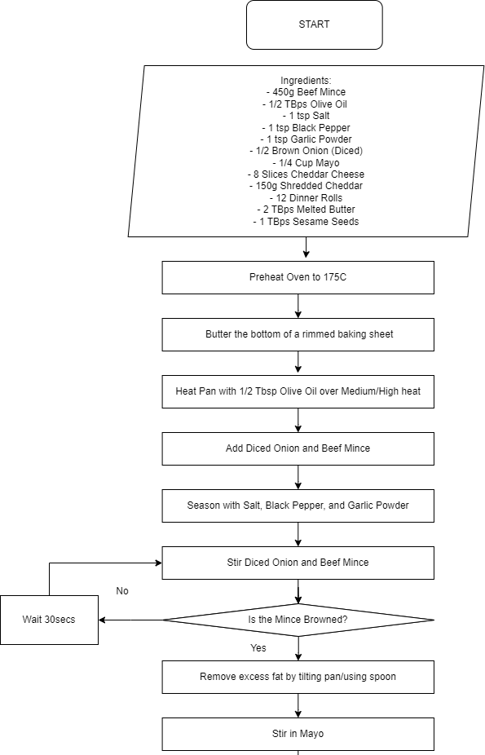

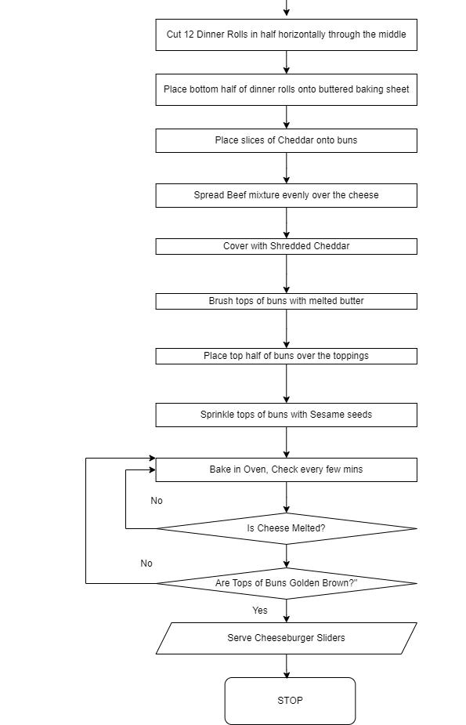

Start  
  
# Starting True/False Variables  
  
salt = true

# Setting up variables   
  
beef_mince = 450 # 450 grams of beef mince

olive_oil = 0.5 # 0.5 tablespoons of Olive Oil

salt = 1 # 1 Teaspoon of Salt

black_pepper = 1 # 1 Teaspoon of Black Pepper

garlic_powder = 1 # 1 Teapsoon of Garlic Powder

brown_onion = 0.5 # Half a Brown Onion

mayo = 0.25 # Quarter of a cup of Mayo

cheddar_slices = 8 # 8 slices of Cheddar Cheese

shredded_cheddar = 150 # 150 Grams of Shredded Cheddar for ontop of Mince

dinner_rolls = 12 # 12 Dinner Rolls

melted_butter = 2 # 2 Tablespoons of Melted Butter

sesame_seeds = 1 # 1 Tablespoon of Sesame Seeds  
  
# End of Variables Setup, Onto the Cooking Method, Initial Preparation

preheat_oven(175) # Step 1) Preheat the Oven to 175C

butter_baking_sheet() # Step 2) Butter a Rimmed baking sheet

melted_butter -= 1 # Reduces melted_butter variable by 1, equalling 1 (was 2)

# Beginning of Preparation to Begin Cooking; Heat the pan and add olive oil

heat_pan(medium_high_heat, olive_oil)

olive_oil -= 0.5 # Reduces olive_oil variable by 0.5, equalling 0 (was 0.5)

# Begin Adding Food to Pan

add_to_pan("onion", brown_onion) # Add Onion to Pan; variable now has function name ‘onion’

add_to_pan("beef", beef_mince) # Add Mince to pan; variable now has function name ‘beef’

brown_onion = 0 # All Onion used; variable is set to 0.

beef_mince = 0 # All Mince used; variable is set to 0.

# Begin seasoning the food in the pan

season(beef, salt, black_pepper, garlic_powder) # Adds Salt, Pepper & Garlic Powder to the pan

salt = 0 # All Salt used; variable is set to 0.

black_pepper = 0 # All Black Pepper used; variable is set to 0.

garlic_powder = 0 # All Garlic Powder used; variable is set to 0.

# Stir Diced Onion and Beef Mince until Mince is Browned

cook(beef, onion)

if beef = not browned then wait = 30 then loop from cook(beef) # 30 = seconds

elseif beef = browned and onion = cooked then continue

# Remove excess fat from pan

remove_excess_fat() # Code can just remove it, however for a human we would tilt the pan.

# Stir mayo into the mince

stir_in_mayo(mayo)

mayo = 0 # All Mayo used; variable is set to 0.

# Cut buns in half horizontally through the middle.

cut_buns_in_half(dinner_rolls)

dinner_rolls = 0 # All Dinner Rolls used; variable is set to 0.

# Place bottom half of buns onto buttered baking sheet

place_buns_on_sheet()

# Place slices of Cheddar noto Buns

add_cheese(cheddar_slices)

cheddar_slices = 0 # All Cheese Slices used; variable is set to 0.

# Spread mince beef mixture over Cheddar

spread_beef_mixture()

# Cover beef with shredded cheddar

cover_with_cheddar(shredded_cheedar)

shredded_cheddar = 0 # All Shredded Cheddar used; variable is set to 0.

# Brush tops of buns with melted butter

brush_with_butter(melted_butter)

melted_butter -= 1 # Reduces melted_butter variable by 1, equalling 0 (was 1)

# Place top half of buns over the toppings

place_top_buns()

# Sprinkle sesame seeds over tops of buns

sprinkle_with_sesame_seeds(sesame_seeds)

sesame_seeds = 0 # All sesame seeds used; variable is set to 0.

# Bake in preheated oven until Cheddar is melted and tops are golden brown

bake(3)

if cheddar_slices = not_melted then loop from bake(3)

elseif golden_brown on top_buns = false then loop from bake(3)

elseif cheddar_slices = melted and golden_brown on top_buns = true, then end

End

Application of Design Possibilities –

Amount of Sliders -

|  |  |  |
| --- | --- | --- |
| Why | How | Psudocode Example |
| This allows a user to adjust the recipe according to their needs in a way that makes sense for larger households. | The code would be designed to account the ‘base ingredients’ as 12, with the users input needing to be multiples of 12. | Input / 12 = Serving_Size  If Serving_Size not a full number (thus not a multiple of 12) then loop to start  Else continue with variables being multiplied by Serving_Size variable. (Flowchart example below.) |

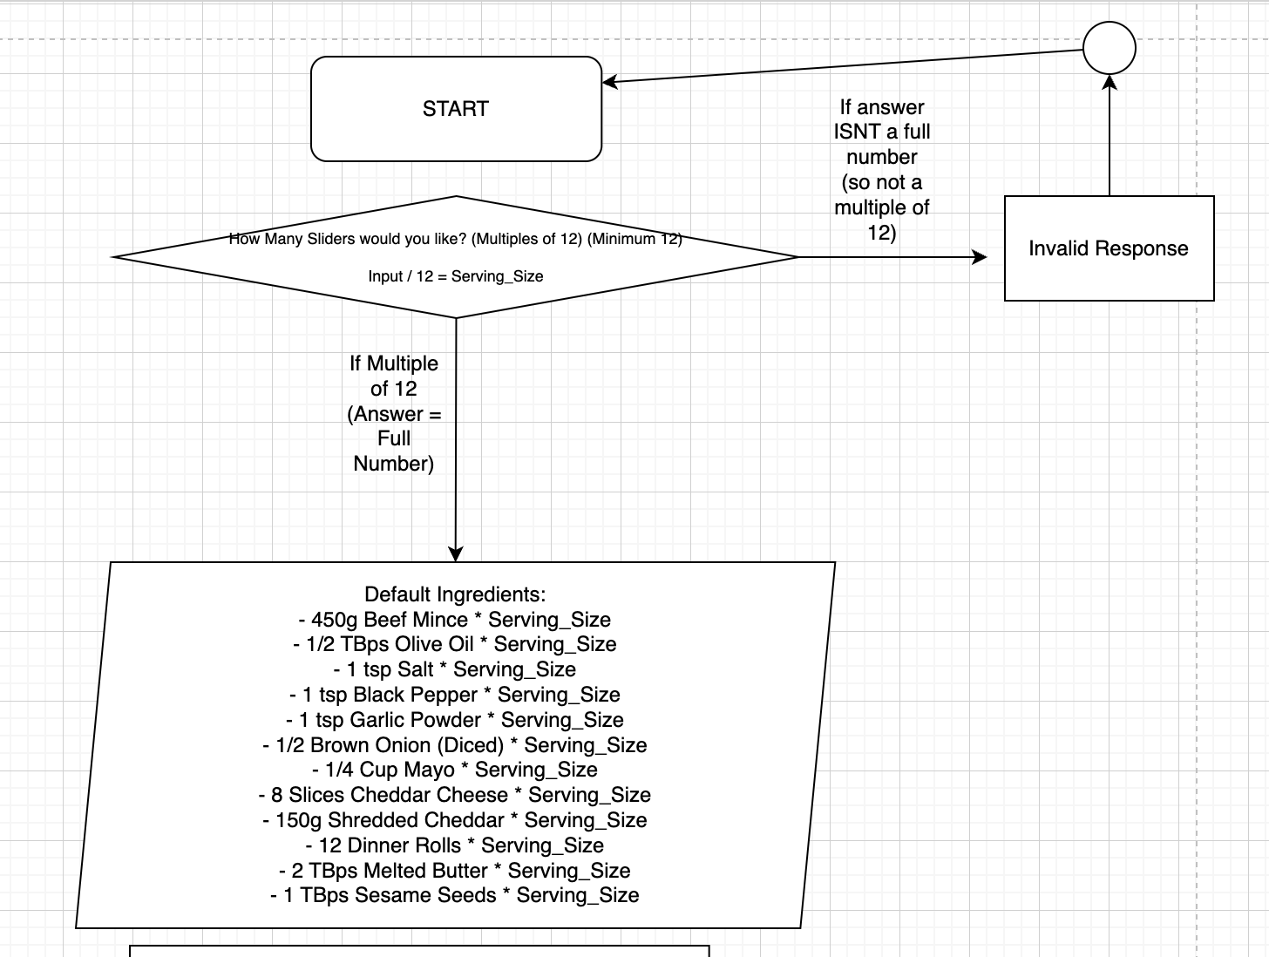Flowchart Example Below -

Adding Ingredients -

|  |  |  |
| --- | --- | --- |
| Why | How | Psudocode Example |
| This gives the user flexibility in their dish to allow them to adjust and create it as they see fit, especially useful after the first time if you ever wish to try the dish again but with a bit of experimentation | User Prompt for additional ingredients after the initial ingredients are shown.  Limits to 1 choice as to not overcrowd the slider.  Will then add in instructions based on variable where to then add it. | Extra_Ingredient = False (When setting variables, false by default)  If ‘1’ input then Extra_Ingredient = True AND Ingredient_Added = Mushroom   If ‘2’ input then Extra_Ingredient = True AND Ingredient_Added = Bacon  If ‘3’ Input then Extra_Ingredient = TRUE AND Ingredient_Added = Tomato  If Extra_Ingredient = True, then print instructions later on, with [Ingredient_Added] (Whatever its name is set to; e.g. Bacon) displaying as the name of the ingredient. |

Flowchart Example Below -

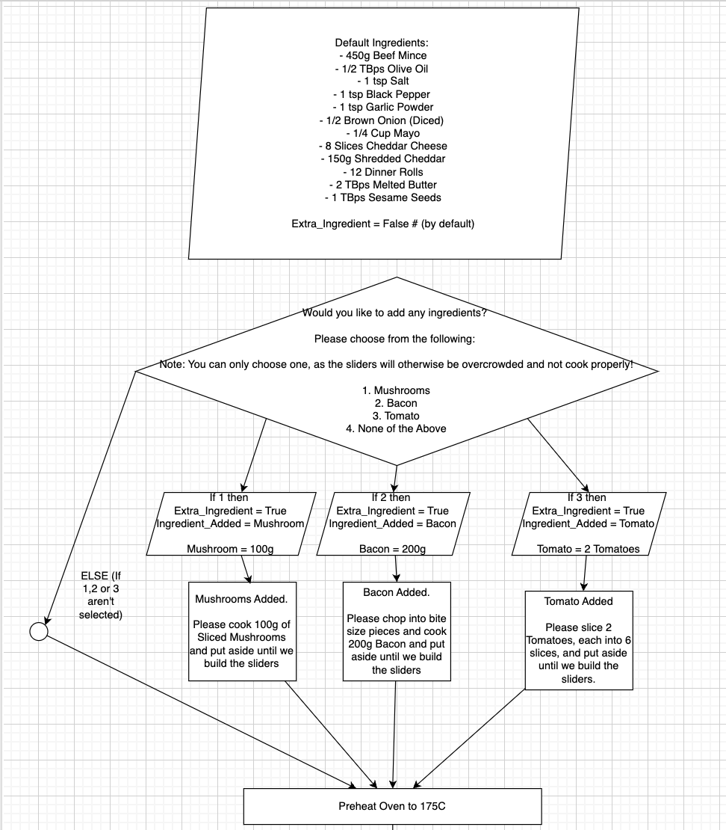

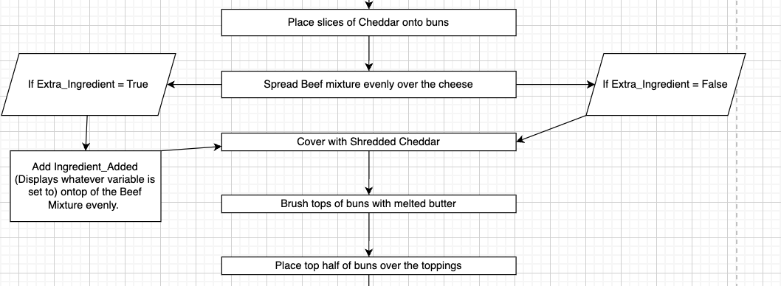

Applying Both Design Possibilities Into One

|  |  |  |
| --- | --- | --- |
| Why | How | Alterations |
| To show a complete understanding of applying design possibilities, I believe it’s important to not just apply things separately, but to think thoroughly about what you are adding, and how it will work when incorporating other additions into the mix.   The Pseudocode will be adjusted from my original code, but made with the new possibilities applied, along with a full updated flowchart. | The script will begin asking how many servings the person wishes to have, and then will ask if they want any extra ingredients prior to showing all of the ingredients. | Firstly, I need to alter how I have setup the ‘Default Ingredients’ to add the other variables, in order to ensure that their values can also be calculated based on serving sizes. For example if I did not do this, and someone wanted 10 servings (120 sliders), and wanted bacon, it would still show 200g of bacon regardless of if its 12, or 120 sliders.  Secondly, There was a bug in my Serving Sizes example where I multiplied the oil which would be used when cooking, which would not be needed and at a certain point would make things too oily and potentially shallow fry the food.   Similarly, I have set salt/pepper to be * Serving Size/2, so that it doesn’t result in the food being over salted/peppered. |

Flowchart Example Complete

`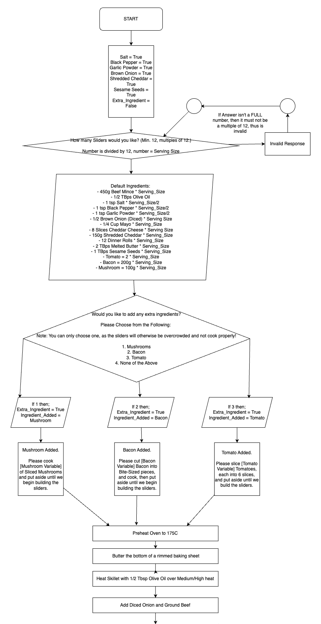

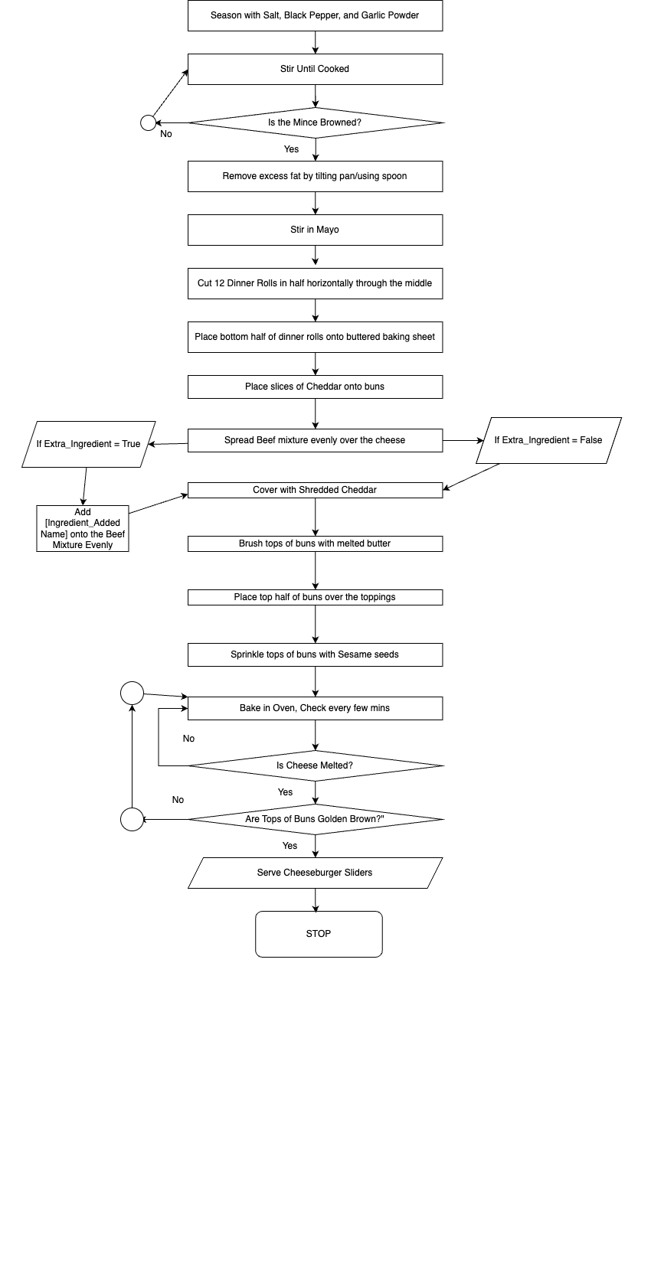

Pseudocode Example Complete

Start  
  
# Starting True/False Variables  
  
salt_check = true  
black_pepper_check = true  
garlic_powder_check = true  
brown_onion_check = true  
shredded_cheddar = true  
sesame_seeds = true  
extra_ingredient = false  
serving_size = 12

Input(“How many sliders would you like? Min. 12, must be in multiples of 12”)

If invalidinput = “The input was not a valid number.” Then loop to start

Else Serving_size = user_input / 12

# Setting up variables   
  
beef_mince = 450 * serving_size # 450 grams of beef mince times Serving Size

olive_oil = 0.5 * serving_size # 0.5 tbps of Olive Oil times Serving Size

salt = 1 * serving_size/2 # 1 Tsp of Salt times times Serving Size, halved if Serving_Size > 1

black_pepper = 1 * serving_size # 1 Tsp of Black Pepper times Serving Size, halved if Serving Size > 1

garlic_powder = 1 * serving_size # 1 Teapsoon of Garlic Powder and halved if Serving Size >1

brown_onion = 0.5 * serving_size # Half a Brown Onion

mayo = 0.25 * serving_size # Quarter of a cup of Mayo

cheddar_slices = 8 * serving_size # 8 slices of Cheddar Cheese

shredded_cheddar = 150 * serving_size # 150 Grams of Shredded Cheddar for ontop of Mince

dinner_rolls = 12 * serving_size # 12 Dinner Rolls

melted_butter = 2 * serving_size # 2 Tablespoons of Melted Butter

sesame_seeds = 1 * serving_size # 1 Tablespoon of Sesame Seeds

tomato = 2 * serving_size # 2 tomatoes times serving_size

bacon = 200 * serving_size # 200 grams times serving_size

# Ensure that if serving is only one that it won’t half the amount of salt/pepper/garlic power needed.

if salt <1 then = 1

if black_pepper <1 then = 1

if garlic_powder <1 then = 1

Input (“Would you like to add any extra ingredients? Please Choose from the Following: Note: You can only choose one, as the sliders will otherwise be overcrowded and not cook properly! 1. Mushrooms 2. Bacon 3. Tomato 4. None of the Above”)   
  
if user_input = 1

extra_ingredient = true  
ingredient_added = mushroom

print(“Mushroom Added. Please cook [integer value of mushroom] of sliced mushrooms and put aside until we begin building the sliders.”)

then continue

if user_input = 2

extra_ingredient = true

ingredient_added = bacon

print(“Tomato added. Please cut [integer value of bacon] bacon into bite-sized pieces and cook, then put aside until we begin building the sliders.”)

then continue

if user_input = 3

extra_ingredient = true  
 ingredient_added = tomato  
 print(“Tomato added. Please slice [integer value of tomato] tomato, each into 6 slices, and put aside until we begin building the sliders.”)

then continue

if user_input = 4 then continue  
  
# End of Variables Setup, Onto the Cooking Method, Initial Preparation

preheat_oven(175) # Step 1) Preheat the Oven to 175C

butter_baking_sheet() # Step 2) Butter a Rimmed baking sheet

melted_butter -= 1 # Reduces melted_butter variable by 1, equalling 1 (was 2)

# Beginning of Preparation to Begin Cooking; Heat the pan and add olive oil

heat_pan(medium_high_heat, olive_oil)

olive_oil -= 0.5 # Reduces olive_oil variable by 0.5, equalling 0 (was 0.5)

# Begin Adding Food to Pan

add_to_pan("onion", brown_onion) # Add Onion to Pan; variable now has function name ‘onion’

add_to_pan("beef", beef_mince) # Add Mince to pan; variable now has function name ‘beef’

brown_onion = 0 # All Onion used; variable is set to 0.

beef_mince = 0 # All Mince used; variable is set to 0.

# Begin seasoning the food in the pan

season(beef, salt, black_pepper, garlic_powder) # Adds Salt, Pepper & Garlic Powder to the pan

salt = 0 # All Salt used; variable is set to 0.

black_pepper = 0 # All Black Pepper used; variable is set to 0.

garlic_powder = 0 # All Garlic Powder used; variable is set to 0.

# Stir Diced Onion and Beef Mince until Mince is Browned

cook(beef, onion)

if beef = not browned then wait = 30 then loop from cook(beef) # 30 = seconds

elseif beef = browned and onion = cooked then continue

# Remove excess fat from pan

remove_excess_fat() # Code can just remove it, however for a human we would tilt the pan.

# Stir mayo into the mince

stir_in_mayo(mayo)

mayo = 0 # All Mayo used; variable is set to 0.

# Cut buns in half horizontally through the middle.

cut_buns_in_half(dinner_rolls)

dinner_rolls = 0 # All Dinner Rolls used; variable is set to 0.

# Place bottom half of buns onto buttered baking sheet

place_buns_on_sheet()

# Place slices of Cheddar onto Buns

add_cheese(cheddar_slices)

cheddar_slices = 0 # All Cheese Slices used; variable is set to 0.

If extra_ingredient = true

Print(“Add [ingredient_added name] onto the beef mixture evenly.”)  
 then continue

Elseif extra_ingredient = false then continue

# Spread mince beef mixture over Cheddar

spread_beef_mixture()

# Cover beef with shredded cheddar

cover_with_cheddar(shredded_cheedar)

shredded_cheddar = 0 # All Shredded Cheddar used; variable is set to 0.

# Brush tops of buns with melted butter

brush_with_butter(melted_butter)

melted_butter -= 1 # Reduces melted_butter variable by 1, equalling 0 (was 1)

# Place top half of buns over the toppings

place_top_buns()

# Sprinkle sesame seeds over tops of buns

sprinkle_with_sesame_seeds(sesame_seeds)

sesame_seeds = 0 # All sesame seeds used; variable is set to 0.

# Bake in preheated oven until Cheddar is melted and tops are golden brown

bake(3)

if cheddar_slices = not_melted then loop from bake(3)

elseif golden_brown on top_buns = false then loop from bake(3)

elseif cheddar_slices = melted and golden_brown on top_buns = true, then end

End

**Conclusion**

I believe that I have adequately not only applied flow charts and pseudocodes, but also effectively applied potential design possibilities that not only convey ideas, but are applied both by themselves, as well as how they would work if they worked together, which included several changes to the script in order to ensure that they are able to work together. For example, I had to shift around some variables from where they were originally placed in order to ensure that the script would continue to function as well as ensuring the new functions would also work correctly.  
  
Another addition I made was true/false variables onto parts of the recipe which could be removed, such as shredded cheese, onion, garlic powder, etc. I felt this was important as in the future if someone (whether that be myself or an entirely different person) were to ever come across my psudocode, they would then have the backend variables ready to create future possibilities such as a function to allow the user to remove certain ingredients. For example, you may be allergic to, dislike, or just not have onion, so they may want to remove it from the step-by-step instructions.   
  
Those variables being for example salt_check, pepper_check, etc.   
  
This is something I feel is extremely important, especially when doing into proper applied coding projects as when working on projects it is very normal to start with a simple base, a 1.0, and then build up on it, with the 2.0 adding both an adjustment for serving sizes, as well as adding an extra ingredient, and a future 3.0 could continue to build upon altering the recipe, removing ingredients, which anyone could do with the variables already being ready for it.

I believe shows a strong form of a design possibility that has not yet been fully realised, and further shows that, much like the normal development cycle of projects and products, even when it feels finished, and even when updates are applied (in this case serving size adjustments and adding ingredients) you can still add and continue to expand upon it.

Most importantly, in the case you choose to stop a project after a few updates as you want to work on something else, if you ever decided to make it open source, it would create a better building block for someone else to take over and to continue to update it, as opposed to adding to the pile of abandonware that often happens.